WEEK NUMBER: | 6
STUDENT NAME: | Anas Al Azad
STUDENT ID: | 105694136
WEEK # |  | 6
Dates covered: |  | 7-13 September 2026
Lab tasks |  | What I did | TIME SPENT | Learning & Problems
Naïve Bayes theory – spam example  Week 6 tutorial sheet |  | - Redid the sheet's example in Python with exact fractions: p(Dear|N) = 8/17 = 0.47 … p(Money|S) = 4/7 = 0.57. score(N) = 0.092 vs score(S) = 0.014 → normal, same as the sheet. Normalising gives P(normal | Dear Friend) = 0.87.  - Made up 12 emails whose word counts add up to the sheet's table and trained sklearn's MultinomialNB on them – exactly the same probabilities (0.871).  - Tried “Lunch Money Money Money Money”: without smoothing it's classed as normal because p(Lunch|Spam) = 0 wipes out the spam score. With Laplace smoothing (α = 1) it's correctly spam (Fig 6.1). | 1.5 h | Learning:  - Posterior ∝ prior × likelihoods; you can skip p(x) when comparing classes.  - “Naïve” = assumes features are independent (word order doesn't matter at all).  - One zero count kills the whole product → always smooth (that's sklearn's alpha).  Problems:  - sklearn needs one row per email, not word totals, so I had to invent emails that match the totals.  - sklearn won't take α = 0 exactly (clips it to 1e-10 with a warning), so I used alpha=1e-10, force_alpha=True for the “no smoothing” version.
Naïve Bayes notebook  Naive_Bayes.ipynb |  | - Ran it: LabelEncoder turns the strings into numbers (Overcast=0, Rainy=1, Sunny=2 / Cool=0, Hot=1, Mild=2 / No=0, Yes=1), zipped weather + temp into features, trained GaussianNB → Predicted Value: [1] (play) for Overcast + Mild.  - Checked it by hand from the counts: score(Yes) = 9/14 × 4/9 × 4/9 = 0.127, score(No) = 5/14 × 0/5 × 2/5 = 0 → Yes ✔.  - Compared GaussianNB with CategoricalNB on all 9 weather × temp combos – they agree on 8, but not on Sunny + Cool (Gaussian: No, Categorical: Yes 0.55). | 1 h | Learning:  - LabelEncoder numbers categories alphabetically.  - GaussianNB assumes each feature is a continuous bell curve, so it treats the 0/1/2 codes like real numbers – CategoricalNB is the right one for categories.  Problems:  - My printed features list looks different from the tutor's: [[np.int64(2), np.int64(1)], …] instead of [[2, 1], …]. It's just how NumPy 2 prints numbers now – same values.
PCA theory + toy example  PCA PDF, pca_extras.ipynb part A |  | - Read the PCA PDF (centre the data, best-fit line through the origin = PC1, PC2 perpendicular, eigenvector/eigenvalue, loading scores, variation = SS/(n−1), scree plot).  - Made my own 6-sample, 2-gene example and found PC1 the PDF's way: tried every line through the origin and kept the one with the biggest SS(distances) → 19.5°, unit vector [0.943, 0.334]. numpy SVD gives [0.942, 0.336] – same line (Fig 6.5).  - PC1 = 96.3% of the variation, PC2 = 3.7%. | 1.5 h | Learning:  - PCA really is “the direction where the projected points are most spread out”.  - “Minimise the distance to the line” = “maximise the projected distance from the origin” – Pythagoras, because each point's distance from the origin is fixed.  - Eigenvalue = SS of the projected distances; variation = eigenvalue / (n−1).  Problems:  - The PDF's example values are only in the pictures, so I couldn't copy its exact data – made my own 6 points instead (so my slope isn't the PDF's 1/4).
PCA notebook  PCA.ipynb + pca_extras.ipynb part B |  | - Ran it: 100 students × 10 random scores (5 maths, 5 physics), scaled, PCA() fit/transform, scree plot and PCA graph.  - Added rd.seed(42) and np.random.seed(42) so I get the same data every run.  - Results: PC1 = 72.9% of the variance (PC2 only 5.6%) (Fig 6.3); the maths and physics scores form two separate clusters along PC1 (Fig 6.4); top loading scores are all ≈ ±0.116 so lots of students contribute equally.  - Did the same PCA by hand (centre + np.linalg.svd) – identical explained variance to sklearn. | 1 h | Learning:  - sklearn's PCA = centring + SVD, nothing magic.  - Scaling first matters, otherwise big-number features dominate.  Problems:  - The original notebook has no seed, so every run gives different data/plots.  - The notebook text says physics is on the left, mine is on the right – PCs only have a direction up to a sign, so plots can come out mirrored.  - Comment says “we create 6 maths scores” but range(1,6) gives 5 (stop is exclusive) – that's why the shape is (100, 10) not (100, 12).
Extra – real datasets  naive_bayes_extras.ipynb E, pca_extras.ipynb C–D |  | - GaussianNB on sklearn's wine data (178 wines, 13 features, 3 classes), 70/30 split: 54/54 test wines correct, 96.8% on the training set (Fig 6.2).  - PCA on iris (4 features): PC1 + PC2 = 95.8% of the variance and setosa separates completely along PC1; loadings show PC1 ≈ petal length/width + sepal length (Fig 6.6).  - PCA on 8×8 digits (64 features): 2 PCs keep only 28.5% and need 29 PCs for 95%, so the 2D plot overlaps a lot. | 1.5 h | Learning:  - NB is super fast and surprisingly good on clean continuous data.  - Whether a 2D PCA plot is useful depends on the scree plot (iris yes, digits not really).  Problems:  - The wine test set is small (54), so 100% is partly luck – a different split would probably miss one or two.
TOTAL TIME THIS WEEK |  |  | 6.5 h

Screenshots:
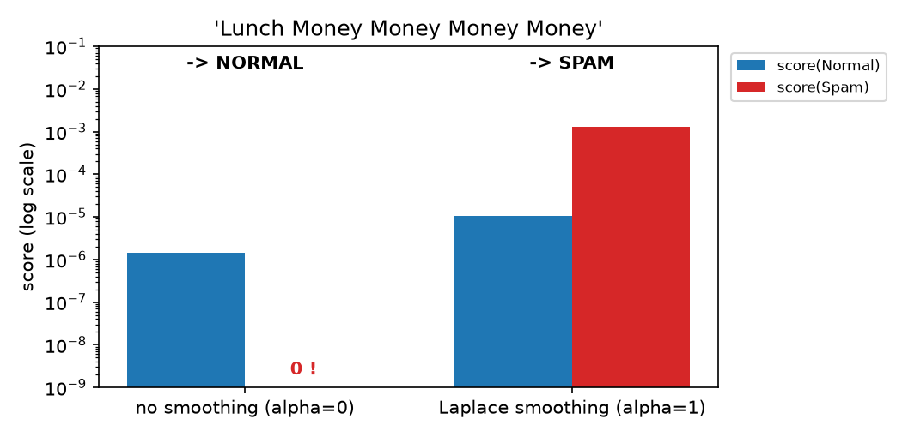
Figure 6.1 – “Lunch Money Money Money Money” – without smoothing the spam score is 0, with Laplace smoothing it's correctly spam
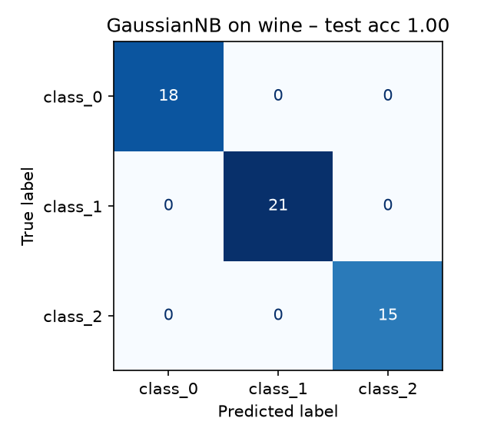
Figure 6.2 – GaussianNB on the wine test set (54 wines) – confusion matrix
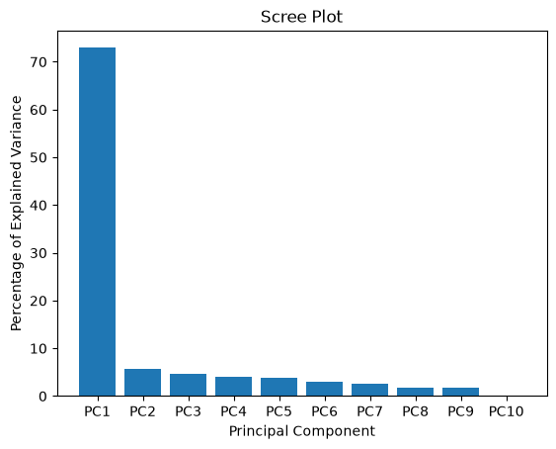
Figure 6.3 – scree plot from PCA.ipynb – PC1 explains 72.9% of the variance
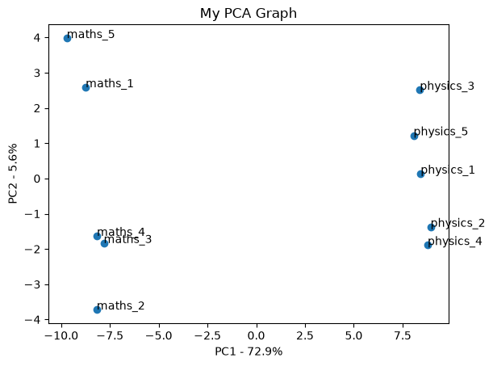
Figure 6.4 – PCA graph from PCA.ipynb – maths and physics scores form two clusters along PC1
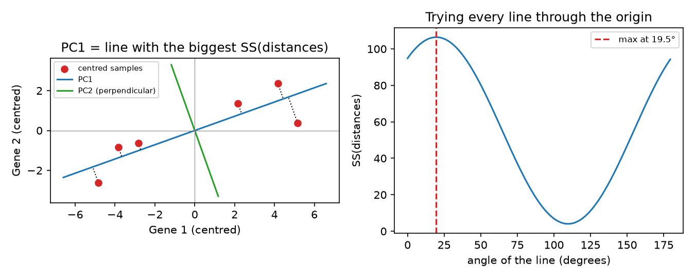
Figure 6.5 – my toy example: PC1 found by trying every line through the origin (max SS) matches SVD
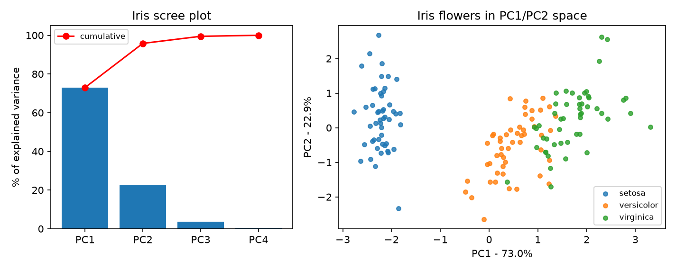
Figure 6.6 – PCA on iris – scree plot and the 150 flowers in PC1/PC2 space
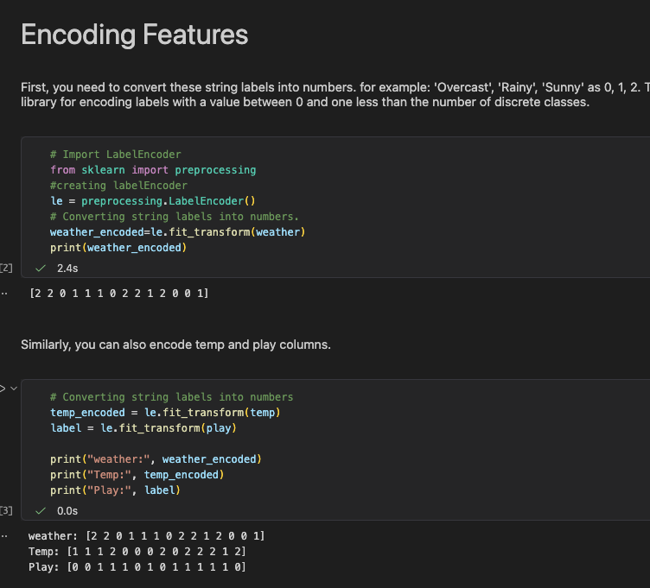
Screenshot 6.1 – Naive_Bayes.ipynb – encoding the features
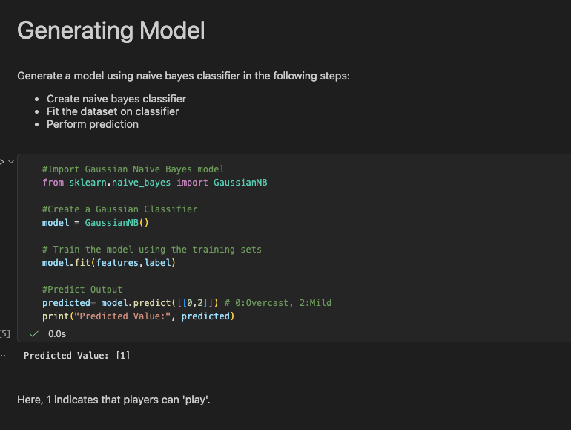
Screenshot 6.2 – Naive_Bayes.ipynb – training + prediction
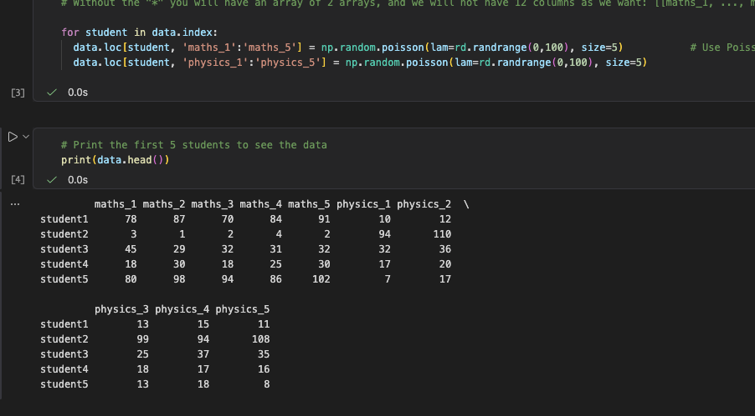Screenshot 6.3 – PCA.ipynb – the generated student data

